**Java SE Project**

YumXpress Application

***OrderFoodFrame Documentation***

1. **OrderFoodFrame–**

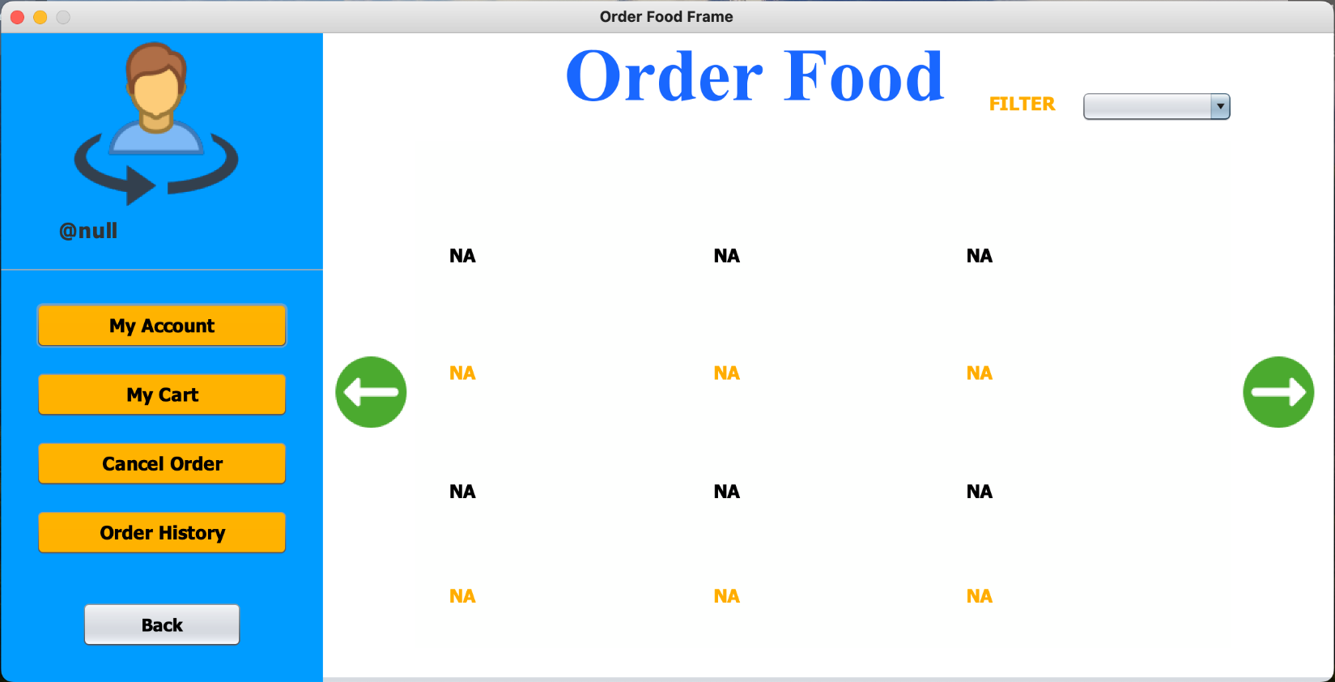

**STEPS TO BE DONE INOrderFoodFrame**

1. **Display the names of all the companies in JComboBox along with the option of ALL.**
2. **Display the Image and food name all the products of the selected company , 6 products at a time. If less than 6 products are there then show N/A in other labels.**
3. **Also provide 🡪 and 🡨 buttons to load next and previous 6 items.**
4. **As the user clicks on any Image , then display a dialog box to the user to select order nowor add to cart.**
5. **If he wishes to place the order immediatley then load the next frame i.e OrderProductFrame showing the details of the food he selected and allow him to order the food.**
6. **If he clicks on add to cart then add the order details int Orders table.**

**BACK END CODE:**

**===============**

Create **ORDERS** table as follows:

**CREATE TABLE ORDERS (**

**ORDER_ID VARCHAR2(10) CONSTRAINT ORDERS_PK PRIMARY KEY,**

**PRODUCT_ID VARCHAR2(10) CONSTRAINT ORD_FK_PID REFERENCES PRODUCTS(PRODUCT_ID),**

**CUSTOMER_ID VARCHAR2(10) CONSTRAINT ORD_FK_CMTR_ID REFERENCES CUSTOMERS(CUSTOMER_ID),**

**STAFF_ID VARCHAR2(10) CONSTRAINT ORD_FK_STF_ID REFERENCES STAFF(STAFF_ID)),**

**REVIEW VARCHAR2(200),**

**STATUS VARCHAR2(50),**

**COMPANY_ID VARCHAR2(20) CONSTRAINT ORD_FK_CMP_ID REFERENCES COMPANIES(COMPANY_ID),**

**OTP NUMBER(10)**

**);**

Create a **Pojo** called **PlaceOrderPojo**with **5 instance variables**:

**public class PlaceOrderPojo {**

**private String orderId;**

**private String productId;**

**private String customerId;**

**private String deliveryStaffId;**

**private String companyId;**

**public PlaceOrderPojo() {**

**}**

**public PlaceOrderPojo(String orderId, String productId, String customerId, String deliveryStaffId, String companyId) {**

**this.orderId = orderId;**

**this.productId = productId;**

**this.customerId = customerId;**

**this.deliveryStaffId = deliveryStaffId;**

**this.companyId = companyId;**

**}**

**public String getProductId() {**

**return productId;**

**}**

**public void setProductId(String productId) {**

**this.productId = productId;**

**}**

**public String getCustomerId() {**

**return customerId;**

**}**

**public void setCustomerId(String customerId) {**

**this.customerId = customerId;**

**}**

**public String getDeliveryStaffId() {**

**return deliveryStaffId;**

**}**

**public void setDeliveryStaffId(String deliveryStaffId) {**

**this.deliveryStaffId = deliveryStaffId;**

**}**

**public String getCompanyId() {**

**return companyId;**

**}**

**public void setCompanyId(String companyId) {**

**this.companyId = companyId;**

**}**

**public String getOrderId() {**

**return orderId;**

**}**

**public void setOrderId(String orderId) {**

**this.orderId = orderId;**

**}**

**@Override**

**public String toString() {**

**return "PlaceOrderPojo{" + "orderId=" + orderId + ", productId=" + productId + ", customerId=" + customerId + ", deliveryStaffId=" + deliveryStaffId + ", companyId=" + companyId + '}';**

**}**

**}**

Define a method called **placeOrder()**in **OrderDAO** which will **add a new order**to the **Orders** table when the user clicks on **OrderNow** button on the **OrderFoodFrame**

**public static String placeOrder(PlaceOrderPojo placeOrder) throws SQLException {**